LUKE SKYWALKER

Luke Skywalker was a Tatooine farmboy who rose from humble beginnings to become one of the greatest Jedi the galaxy has ever known. Along with his friends Princess Leia and Han Solo, Luke battled the evil Empire, discovered the truth of his parentage, and ended the tyranny of the Sith. A generation later, the location of the famed Jedi master was one of the galaxy’s greatest mysteries.

APPEARANCES

Star Wars: Episode IV A New Hope, Star Wars: Episode V The Empire Strikes Back, Star Wars: Episode VI Return of the Jedi, Star Wars: Episode III Revenge of the Sith, Star Wars: Episode VII The Force Awakens, Star Wars: Episode VIII The Last Jedi, Star Wars Rebels

AFFILIATIONS

Rebel Alliance, Jedi Order

LOCATIONS

Polis Massa, Lars Moisture Farm, Tatooine

GENDER

Male

DIMENSIONS

Height: 1.72m

SPECIES

Human

WEAPONS

Blaster Pistol, Lightsaber, Luke Skywalker's Lightsaber (Green Blade), Anakin, Luke, and Rey's Lightsaber

VEHICLES

T-16 Skyhopper, X-34 Landspeeder, X-wing Starfighter, Snowspeeder

TOOL

Bacta Tank, Moisture Vaporator

KYLO REN

A dark warrior strong with the Force, Kylo Ren commands First Order missions with a temper as fiery as his unconventional lightsaber. As a leader of the First Order and a student of Supreme Leader Snoke, he seeks to destroy the New Republic, the Resistance and the legacy of the Jedi.

APPEARANCES

Star Wars: Episode VII The Force Awakens, Star Wars: Episode VIII The Last Jedi

AFFILIATIONS

The First Order

GENDER

Male

SPECIES

Human

VEHICLES

Kylo Ren's Command Shuttle, Finalizer, TIE silencer

WEAPONS

Kylo Ren's Lightsaber

LEIA ORGANA

Princess Leia Organa was one of the Rebel Alliance’s greatest leaders, fearless on the battlefield and dedicated to ending the tyranny of the Empire. Daughter of Padmé Amidala and Anakin Skywalker, sister of Luke Skywalker, and with a soft spot for scoundrels, Leia ranks among the galaxy’s great heroes. But life under the New Republic has not been easy for Leia. Sidelined by a new generation of political leaders, she struck out on her own to oppose the First Order as founder of the Resistance. These setbacks in her political career have been accompanied by more personal losses.

APPEARANCES

Star Wars: Episode IV A New Hope, Star Wars: Episode V The Empire Strikes Back, Star Wars: Episode VI Return of the Jedi, Star Wars: Episode III Revenge of the Sith, Star Wars: Episode VII The Force Awakens, Rogue One: A Star Wars Story, Star Wars: Episode VIII The Last Jedi, Star Wars Rebels

AFFILIATIONS

Rebel Alliance, The Resistance, Galactic Senate, Alderaan Royal Family

LOCATIONS

Alderaan, Polis Massa

GENDER

Female

DIMENSIONS

Height: 1.5m

SPECIES

Human

VEHICLES

Tantive IV

WEAPONS

Blaster Pistol

FINN

FN-2187 was trained since birth to serve the First Order as a stormtrooper, but a skirmish on Jakku awakened his conscience and drove him down a different path, one that proved both heroic and dangerous. He helped Poe Dameron escape the First Order – picking up the nickname Finn in doing so – and then sought his own freedom alongside Rey and BB-8.

APPEARANCES

Star Wars: Episode VII The Force Awakens, Star Wars: Episode VIII The Last Jedi

AFFILIATIONS

The First Order

GENDER

Male

DIMENSIONS

Height: 1.78m

SPECIES

Human

WEAPONS

Lightsaber, Blaster Rifle

BB-8

A skittish but loyal astromech, BB-8 accompanied Poe Dameron on many missions for the Resistance, helping keep his X-wing in working order. When Poe’s mission to Jakku ended with his capture by the First Order, BB-8 fled into the desert with a vital clue to the location of Jedi Master Luke Skywalker.

APPEARANCES

Star Wars: Episode VII The Force Awakens, Star Wars: Episode VIII The Last Jedi, Star Wars: Forces of Destiny

AFFILIATIONS

The Resistance

DIMENSIONS

Height: 0.67m

DROID

Astromech Droid

C-3PO (SEE-THREEPIO)

C-3PO is a droid programmed for etiquette and protocol, built by the heroic Jedi Anakin Skywalker, and a constant companion to astromech R2-D2. Over the years, he was involved in some of the galaxy’s most defining moments and thrilling battles -- and is fluent in more than seven million forms of communication. In the years after the Empire's defeat, C-3PO acquired a red-plated arm, keeping the mismatched limb to honor a fellow droid's sacrifice.

APPEARANCES

Star Wars: Episode II Attack of the Clones, Star Wars: Episode III Revenge of the Sith, Star Wars: Episode V The Empire Strikes Back, Star Wars: Episode I The Phantom Menace, Star Wars: Episode IV A New Hope, Star Wars: Episode VI Return of the Jedi, Star Wars: Episode VII The Force Awakens, Rogue One: A Star Wars Story, Star Wars Rebels, Star Wars: The Clone Wars

AFFILIATIONS

The Resistance

LOCATIONS

Tatooine

DROID

Protocol Droid

TOOL

Restraining Bolt

CHEWBACCA

A legendary Wookiee warrior and Han Solo’s co-pilot aboard the Millennium Falcon, Chewbacca was part of a core group of Rebels who restored freedom to the galaxy. Known for his short temper and accuracy with a bowcaster, Chewie also has a big heart -- and is unwavering in his loyalty to his friends. He has stuck with Han through years of turmoil that have changed both the galaxy and their lives.

APPEARANCES

Star Wars: Episode IV A New Hope, Star Wars: Episode V The Empire Strikes Back, Star Wars: Episode VI Return of the Jedi, Star Wars: Episode III Revenge of the Sith, Star Wars: Episode VII The Force Awakens, Star Wars: The Clone Wars

AFFILIATIONS

Rebel Alliance

LOCATIONS

Kashyyyk

GENDER

Male

DIMENSIONS

Height: 2.28m

SPECIES

Wookiee

VEHICLES

Millennium Falcon, The Eravana

WEAPONS

Bowcaster

DARTH VADER

Once a heroic Jedi Knight, Darth Vader was seduced by the dark side of the Force, became a Sith Lord, and led the Empire’s eradication of the Jedi Order. He remained in service of the Emperor -- the evil Darth Sidious -- for decades, enforcing his Master’s will and seeking to crush the fledgling Rebel Alliance. But there was still good in him…

APPEARANCES

Star Wars: Episode III Revenge of the Sith, Star Wars: Episode V The Empire Strikes Back, Star Wars: Episode IV A New Hope, Star Wars: Episode VI Return of the Jedi, Rogue One: A Star Wars Story, Star Wars Rebels

AFFILIATIONS

Galactic Empire, Sith

LOCATIONS

Death Star, Death Star II

GENDER

Male

DIMENSIONS

Height: 2.03m

SPECIES

Human

VEHICLES

Darth Vader's TIE Fighter

WEAPONS

Darth Vader's lightsaber

HAN SOLO

Smuggler. Scoundrel. Hero. Han Solo, captain of the Millennium Falcon, was one of the great leaders of the Rebel Alliance. He and his co-pilot Chewbacca came to believe in the cause of galactic freedom, joining Luke Skywalker and Princess Leia Organa in the fight against the Empire. But after the Battle of Endor, Han would face difficult times in a galaxy plagued by chaos and uncertainty.

APPEARANCES

Star Wars: Episode IV A New Hope, Star Wars: Episode V The Empire Strikes Back, Star Wars: Episode VI Return of the Jedi, Star Wars: Episode VII The Force Awakens

AFFILIATIONS

Rebel Alliance

LOCATIONS

Mos Eisley Spaceport, Corellia

GENDER

Male

DIMENSIONS

Height: 1.8m

SPECIES

Human

WEAPONS

Blaster Pistol

VEHICLES

Millennium Falcon, The Eravana

JAR JAR BINKS

A clumsy, well-meaning Gungan outcast on Naboo, Jar Jar Binks struggled to prove his worth throughout his life. Putting his awkward past behind him, Jar Jar left the swamps of Naboo to enter the even murkier waters of Coruscant politics, becoming a representative for his people in the galactic capital. There, his best intentions and eagerness to serve were exploited by scheming Senators and others in positions of power.

APPEARANCES

Star Wars: Episode I The Phantom Menace, Star Wars: Episode II Attack of the Clones, Star Wars: Episode III Revenge of the Sith, Star Wars: The Clone Wars

AFFILIATIONS

Gungan Grand Army, Galactic Republic

LOCATIONS

Naboo

GENDER

Male

DIMENSIONS

Height: 1.96m

SPECIES

Gungan

VEHICLES

Gungan Bongo Submarine

WEAPONS

Energy Ball (Booma), Electropole

OBI-WAN KENOBI

A legendary Jedi Master, Obi-Wan Kenobi was a noble man and gifted in the ways of the Force. He trained Anakin Skywalker, served as a general in the Republic Army during the Clone Wars, and guided Luke Skywalker as a mentor.

APPEARANCES

Star Wars: Episode II Attack of the Clones, Star Wars: Episode III Revenge of the Sith, Star Wars: Episode V The Empire Strikes Back, Star Wars: Episode I The Phantom Menace, Star Wars: Episode IV A New Hope, Star Wars: Episode VI Return of the Jedi, Star Wars Rebels, Star Wars: The Clone Wars

AFFILIATIONS

Jedi Order

LOCATIONS

Obi-Wan's House, Stewjon

GENDER

Male

DIMENSIONS

Height: 1.82m

WEAPONS

Lightsaber, Obi-Wan Kenobi's Lightsabers

VEHICLES

Jedi Starfighter

R2-D2

A resourceful astromech droid, R2-D2 served Padmé Amidala, Anakin Skywalker and Luke Skywalker in turn, showing great bravery in rescuing his masters and their friends from many perils. A skilled starship mechanic and fighter pilot's assistant, he formed an unlikely but enduring friendship with the fussy protocol droid C-3PO.

APPEARANCES

Star Wars: Episode II Attack of the Clones, Star Wars: Episode III Revenge of the Sith, Star Wars: Episode V The Empire Strikes Back, Star Wars: Episode IV A New Hope, Star Wars: Episode I The Phantom Menace, Star Wars: Episode VI Return of the Jedi, Star Wars: Episode VII The Force Awakens, Rogue One: A Star Wars Story, Star Wars Rebels, Star Wars: The Clone Wars

AFFILIATIONS

Rebel Alliance, Galactic Republic

LOCATIONS

Naboo, Havoc Outpost

DIMENSIONS

Height: 1.09m

DROID

Astromech Droid

VEHICLES

X-wing Starfighter, Jedi Starfighter

TOOL

Restraining Bolt

REY

Rey is a Jakku scavenger, a survivor toughened by life on a harsh desert planet. When the fugitive droid BB-8 appeals to her for help, Rey finds herself drawn into a galaxy-spanning conflict. Despite dismissing herself as “no one,” she learns that her life is being shaped by the mysterious power of the Force.

APPEARANCES

Star Wars: Episode VII The Force Awakens, Star Wars: Episode VIII The Last Jedi, Star Wars: Forces of Destiny

LOCATIONS

Jakku, Goazon Badlands, Rey's Home

GENDER

Female

DIMENSIONS

Height: 1.7m

SPECIES

Human

WEAPONS

Lightsaber, Blaster Pistol, Rey's Blaster, Rey's Quarterstaff

VEHICLES

Rey's Speeder

YODA

Yoda was a legendary Jedi Master and stronger than most in his connection with the Force. Small in size but wise and powerful, he trained Jedi for over 800 years, playing integral roles in the Clone Wars, the instruction of Luke Skywalker, and unlocking the path to immortality.

APPEARANCES

Star Wars: Episode II Attack of the Clones, Star Wars: Episode III Revenge of the Sith, Star Wars: Episode V The Empire Strikes Back, Star Wars: Episode I The Phantom Menace, Star Wars: Episode VI Return of the Jedi, Star Wars Rebels, Star Wars: The Clone Wars

AFFILIATIONS

Jedi Order

LOCATIONS

Yoda's Hut

GENDER

Male

DIMENSIONS

Height: 0.66m

SPECIES

Unknown

WEAPONS

Lightsaber, Yoda's Lightsaber

VEHICLES

Yoda's Fighter

Planets

Naboo

The rolling hills and tranquil waterfalls of Naboo provided beautiful scenery, but they also represented the peaceful nature of the time before the Trade Federation’s invasion, the Clone Wars, and the rise of the Galactic Empire. When first introduced in The Phantom Menace, Naboo was blockaded by the Trade Federation and Darth Sidious was beginning his subtle manipulations for his ascent to power. A brief glimpse of Naboo is shown prior to the landing of troops by the Trade Federation, but soon the planet’s natural wonders were seen being ravaged by battles and the machines of war. The arrival of conflict heralded the broader struggles to come, when the fighting would spread into the far reaches of the galaxy.

Region: Mid Rim

Sector: Chrommell Sector

System: Naboo System

Inhabitants: Elders, Gungans, Humans (Naboo)

Capital City: Otho Gunga (Gungan), Theed (Human)

SIZE: 12,120

POPULATION: 4,500,000,000

ORBITAL PERIOD: 312

ROTATION PERIOD: 26

CLIMATE: TEMPERATE

TERRAIN: GRASSY HILLS, SWAMPS, FORESTS, MOUNTAINS

Eadu

Of the many new planets Rogue One introduced into the Star Wars mythos, one may already look very familiar. After Jyn Erso’s crew escapes Jedha, they must continue on to the planet of Eadu to complete their mission. Home to the Empire’s secret kyber crystal refinery, the planet’s hard to navigate canyons and intense weather patterns make landing not so easy. With a storm system constantly raging overhead, the planet’s surface is dark with a purple hue.

Region: Outer Rim Terriroties

Sector: Bheriz Sector

System: Eadu System

Inhabitants: Humans

Capital City: Unknown

Kashyyyk

From the earliest drafts of The Star Wars, the Wookiee planet of Kashyyyk would not give up trying to get into the saga. Originally slated for A New Hope, then introduced haphazardly in The Star Wars Christmas Special, fans would have to wait until 2005 to finally see the giant tree canopies that George Lucas and Ralph McQuarrie had envisioned.

In Revenge of the Sith, the final battles of the Clone Wars are coming to a head. As the wookiees fight the Separatists off their homeworld they are joined by Jedi Master Yoda. We get our first real look at the the planet’s massive forests of wroshyr trees as the camera sweeps over the beachhead where the climactic battle will take place, ending in Order 66.

Region: Mid Rim

Sector: Mytaranor Sector

System: Kashyyyk System

Inhabitants: Wookiees

Capital City: Unknown

SIZE: 12,765

POPULATION: 45,000,000

ORBITAL PERIOD: 381

ROTATION PERIOD: 26

CLIMATE: TROPICAL

TERRAIN: JUNGLE, FORESTS, LAKES, RIVERS

Alderaan

No scene in the history of cinema has better demonstrated the stakes of a film than the destruction of Princess Leia’s home planet of Alderaan. When the daughter of the planet’s Senator Bail Organa is forced to choose between revealing the location of the Rebel base and saving the planet, Leia gives Moff Tarkin the location of a former base on Dantooine. Unfazed, Moff Tarkin continues with the destruction of the pacifist planet. The devastation of which would be felt across the galaxy by Jedi Obi Wan Kenobi. The Special Edition re release of the films found the explosion getting an extra piece of flare in a ring emitting from the blast.

We would go on to meet the Senator in Episode II, but we wouldn’t actually visit the planet until the very end of Revenge of the Sith. In a scene where Jimmy Smits’ Bail Organa is introducing his adopted daughter Leia to his wife we see the peaceful countryside of the planet and imagine the supportive happy family they would become while planning revolutionary rebellions throughout the galaxy.

Region: Core Worlds

Sector: Alderaan Sector

System: Alderaan System

Inhabitants: Humans

Capital City: Aldera

SIZE: 12,500

POPULATION: 2,000,000,000

ORBITAL PERIOD: 364

ROTATION PERIOD: 24

CLIMATE: TEMPERATE

TERRAIN: GRASSLANDS, MOUNTAINS

Geonosis

Deeply entrenched in Star Wars lore the planet Geonosis is the site of the first battle of the Clone Wars. Count Dooku and the Geonosians were building a droid army on the planet. After Obi Wan, Anakin and Padme Amidala are captured, Republic forces, led by Yoda charge into battle. In the final scenes of Revenge of the Sith, the Death Star’s plans are taken to Geonosis to begin initial construction. While Geonosis didn’t show up in Rogue One, it has been a major part of connecting the Death Star’s story to the larger universe on Rebels. In the fan-favorite episode “The Honorable Ones”, the crew of the Ghost journey to Geonosis only to find Imperial building platforms orbiting the now-dead planet. The secret weapons project that started here had moved on years ago, leaving the planet “sterilized” by bombardment. The 3rd season finale, “Ghosts of Geonosis”, is expected to connect the dots on how the Death Star got from Geonosis to Rogue One when the Rebels crew returns to the planet.

Region: Outher Rim Terriroties

Sector: Arkanis Sector

System: Geonosis System

Inhabitants: Acklay, Geonosians, Massiff, Nexu, Reek

Capital City: Stalgasin

SIZE: 11,370

POPULATION: 100,000,000,000

ORBITAL PERIOD: 256

ROTATION PERIOD: 30

CLIMATE: TEMPERATE, ARID

TERRAIN: ROCK, DESERT, MOUNTAIN, BARREN

Kamino

One of Chancellor Palpatine’s meticulously crafted plans involved the secret creation of a clone army, which brought Obi-Wan Kenobi to the seas of Kamino. The dark clouds, torrential rain, and turbulent waters foreshadowed the turmoil of the Clone Wars that were about to begin, as the very clones who would fight on the Republic’s behalf were created and trained on Kamino’s surface installations. During his fight with Jango Fett, Obi-Wan almost tumbled into the ferocious sea, yet again signifying the impending fall of the Republic that would be brought about by the Clone Wars.

Region: Beyond the Rishi Maze

Sector: Abrion Sector

System: Kamino System

Inhabitants: Kaminoans

Capital City: Tipoca City

SIZE: 19,720

POPULATION: 1,000,000,000

ORBITAL PERIOD: 463

ROTATION PERIOD: 27

CLIMATE: TEMPERATE

TERRAIN: OCEAN

Dagobah

At first glance, the swampy waters of Dagobah seemed like an inhospitable place to reside. However, when considering the fact that this was Yoda’s home and the location where Luke Skywalker received the majority of his training, the importance of the surroundings can be found. Filled with primitive lifeforms and primordial waters, Dagobah was thick with the energy from which Jedi draw their strength. While no advanced civilizations stayed there, the simple creatures embodied the initiation of Luke’s formal training and the start of the light’s return to prestige.

Region: Outher Rim Terriroties

Sector: Sluis Sector

System: Dagobah System

Inhabitants: Unknown

Capital City: Unknown

SIZE: 8,900

POPULATION: UNKNOWN

ORBITAL PERIOD: 341

ROTATION PERIOD: 23

CLIMATE: MURKY

TERRAIN: SWAMP, JUNGLES

Jedha

Many moons in the universe are possibly more hospitable to life than some of the massive and dangerous gas giants they orbit. In the latest Star Wars film Rogue One, the traditional Star Wars desert planet is replaced by, wait for it, a desert moon. Those who worship the force journey to Jedha City’s Temple to commune with the spiritual energy that binds us all and in the case of Jedi, receive kyber crystals for their lightsabers. After the rise of Palpatine and the extermination of the Jedi from the galaxy, Jedha was all that remained of the hokey religion. The Empire strip mined Ilum (the location of kyber crystals in Star Wars: Clone Wars) of its kyber resources and then set its eyes on Jedha’s stockpile of the energy source. The Imperial occupation of Jedha would lead to an insurgency led by Rebel extremist Saw Gerrera. Gerrera’s relationship with the greater Rebellion is strained because of his merciless tactics, but his relationship with the Erso family brings him back into the fold. Jedha is also home to the Guardians of the Whills. In original drafts of Star Wars, the Whills were invisible beings observing the universe. Eventually they just became the Force. In Rogue One, the Guardians of the Whills serve as non-force adept protectors of the Jedi temple. With the temple ransacked by the Empires, all they can do is fight Imperial forces in the streets of Jedha.

Hoth

Despite the destruction of the Death Star, the Rebel Alliance was found to be on the run and hiding on the snow-covered sphere of Hoth at the beginning of The Empire Strikes Back. The icy wasteland, with its frigid temperatures and vicious wampas, represented the precarious and deadly situation the Rebellion faced as the Empire dedicated its forces to tracking the location of the freedom fighters. The powerful superweapon had been eradicated, but the Rebels still faced an uphill battle against their foes. In a more literal sense, the very existence of the Rebel Alliance was on thin ice, as its potential extermination on Hoth could have spelled the end of their cause.

Region: Outher Rim Terriroties

Sector: Anoat Sector

System: Hoth System

Inhabitants: Unknown

Capital City: Unknown

SIZE: 7,200

POPULATION: UNKNOWN

ORBITAL PERIOD: 549

ROTATION PERIOD: 23

CLIMATE: FROZEN

TERRAIN: TUNDRA, ICE CAVES, MOUNTAIN RANGES

Endor

In a similar fashion, the intelligent Ewoks and bright skies on the forest moon of Endor signified the completion of Luke’s education as a Jedi and the triumph over the darkness in Return of the Jedi. The complex forms of life paralleled the strength gained by the light as the Emperor perished and Darth Vader was revitalized as Anakin Skywalker. The imagery of the second Death Star’s glowing, sun-like explosion appearing in the clear, blue sky also supported the concept that the light side of the Force was victorious.

Region: Outher Rim Terriroties

Sector: Moddell Sector

System: Endor System

Inhabitants: Unknown

Capital City: Unknown

SIZE: 4,900

POPULATION: 30,000,000

ORBITAL PERIOD: 402

ROTATION PERIOD: 18

CLIMATE: TEMPERATE

TERRAIN: FORESTS, MOUNTAINS, LAKES

Bespin

The idea of extracting valuable natural resources from gas giants like Saturn or Jupiter have been around since the birth of science fiction. In the Star Wars universe, Bespin is one such planet. On the run from the Empire, Han Solo and company would fly to Bespin in search of an old friend. Originally in the running for the role of Han, Billy Dee Williams would join the trilogy as Lando Calrissian, a former owner of the Millennium Falcon and administrator of the mining facility Cloud City. Bespin would be the site of a trap by Boba Fett and the Empire to capture Luke, but not before testing the planned shipping procedure of carbon freezing on Han Solo. Showing his true colors as a man of honor trying to save the lives of everyone on the facility, Lando called for an evacuation of Cloud City. Meanwhile, in the bowels of the station, Luke would discover the truth about Darth Vader and his father. Vader is his father, though German audiences kind of saw it coming. Calrissian would become a General in the Rebellion, possibly getting promoted quickly thanks to his help in the resistance on Rebels.

Region: Outher Rim Terriroties

Sector: Anoat Sector

System: Bespin System

Inhabitants: Humans, Ugnaughts

Capital City: Unknown

SIZE: 23,600

POPULATION: 6,000,000

ORBITAL PERIOD: 5110

ROTATION PERIOD: 12

CLIMATE: TEMPERATE

TERRAIN: GAS GIANT

Mustafar

Once the Republic’s fate had been sealed, Obi-Wan and Darth Vader faced off in an epic duel on the volcanic surface of Mustafar. The deadly lava fields, thick clouds of ash, and blackened soil were indicators of the imposing evil of the emerging Galactic Empire in Revenge of the Sith. Although he had already been given the name Darth Vader, Anakin received his true baptism as a Sith Lord in the fires of Mustafar. As the flames charred his body, they were creating the severe health conditions that would require Darth Vader to don his infamous life-support armor, which later served as a symbol of the Empire’s ruthless nature.

Region: Outher Rim Terriroties

Sector: Atravis Sector

System: Mustafar System

Inhabitants: Mustafarian

Capital City: Fralideja

Jakku

As with the conditions on Tatooine, the lifeless deserts and unkept junkyards of Jakku reflected the notion that the remnants of the Galactic Civil War remained and foreshadowed the endurance of the Empire’s influence in The Force Awakens. The New Republic’s inefficiency in cleaning up old battlefields mirrored its inability to recognize that Imperial sympathizers were still a considerable threat to peace, especially in the form of the First Order. By not taking direct action to quell the efforts of those who idolized the fallen Empire, the New Republic gave the First Order the opportunity to expand its ranks, bolster its fleet, and construct the incredible weapon known as Starkiller Base.

Region: Western Reaches

Sector: Unknown

System: Jakku System

Inhabitants: Abednedo, Crolute, Humans, Hutt, Kyuzo, Melitto,Nu-Cosian, Teedo, Uthuthma

Capital City: Unknown

Scarif

The final act of Rogue One is filled with moments Star Wars fans have waited a lifetime to see. With the threat of the Death Star looming, Jyn Erso and her band of Rogues must infiltrate an Imperial data center on the tropical world of Scarif. Trying to sneak into an imperial base loaded down with a battalion of Storm & Shoretroopers, the volunteer Rebel unit must create a distraction to draw out the overwhelming force; giving Jyn Erso and Cassian Andor an opportunity to sneak into the massive Imperial data bank tower. The Rebel fleet would engage the Empire en masse for the first time in orbit around Scarif, trying desperately to get support through shield to Rogue One below.

Region: Outher Rim Terriroties

Sector: Abrion Sector

System: Unknown

Inhabitants: Humans

Capital City: Unknown

Coruscant

The metropolitan sprawl of Coruscant was picturesque when viewed from the skies in Attack of the Clones, but the lower levels were filled with crime, poverty, and grueling conditions. This dichotomy was a summation of the Republic’s woes, as the outward presentation of stability was being undercut by the evils of Darth Sidious. The Jedi Council, in its chambers on the surface, was suspicious of the influence of a Sith Lord, yet they did not realize how deep the corruption ran.

Region: Core Worlds

Sector: Corusca Sector, Coruscant Subsector

System: Coruscant System

Inhabitants: Many Types

Capital City: Galactic City

SIZE: 12,240

POPULATION: 1,000,000,000,000

ORBITAL PERIOD: 368

ROTATION PERIOD: 24

CLIMATE: TEMPERATE

TERRAIN: CITYSCAPE, MOUNTAINS

Yavin 4

On the jungle moon of Yavin 4, ancient temples of the Massassi warriors stood empty until the Rebel Alliance had need of a secret base from which to strike at the Empire. The Massassi were an ancient race enslaved by the Sith. While no longer canon, the temples would go on to be used as Luke Skywalker’s Jedi Academy, though the previous tenants would cause the dark side of the force to grow very strong in the temples catacombs. The rebellion would meet Jyn Erso at the base for the first time, giving her the mission to find her father and the plans for the Death Star. Launching the successful raid on the Imperial battle station, the Rebels were able to hold the position after Luke Skywalker’s final blow to the facility. Before scuttling the base and going on the run as a flotilla then eventually landing on Hoth, the Rebels would take a moment to celebrate their first decisive win against the Empire.

Region: Outher Rim Terriroties

Sector: Gordian Reach

System: Yavin System

Inhabitants: Unknown

Capital City: Unknown

SIZE: 10,200

POPULATION: 1,000

ORBITAL PERIOD: 4818

ROTATION PERIOD: 24

CLIMATE: TEMPERATE, TROPICAL

TERRAIN: JUNGLE, RAINFORESTS

Tatooine

The decrepit streets of Mos Eisley and the sterile rocks of the Jundland Wastes fit in perfectly with the barren nature of the deserts of Tatooine in A New Hope. The two things that most people on the planet had in common were unhappiness and a desire to leave. These torrid surroundings, introduced at a time when the Rebellion was growing, reflected the general misery and discontent that the Empire had engendered during its rule. The discomfort displayed by many citizens at the arrival of stormtroopers was another sign of unfavorable views toward Imperials.

Region: Outher Rim Terriroties

Sector: Arkanis Sector

System: Tatoo System

Inhabitants: Aqualish, Bith, Dug, Humans, Hutts, Jawas, Nikto, Rodian, Talz, Twi`lek, Tusken Raiders, Weequays, various other

Capital City: Unknown

SIZE: 10,456 km

POPULATION: 80,000-200,000

ORBITAL PERIOD: 304

ROTATION PERIOD: 23

CLIMATE: TROPICAL

TERRAIN: Desert, Some oases, Mesas, Buttes, Canyons, Formerly: oceans, rainforests

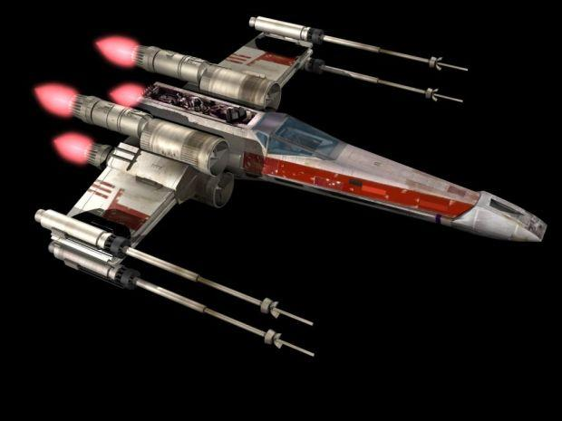

**X-Wing**

*First Appearance: A New Hope*

As the starship battles in***A New Hope*** were modeled after real-world dogfights, X-Wings fit the role of the quick, darting fighter planes that fought in them. Their maneuverability and the split wings that match the X in their name make them one of the coolest starship designs in ***Star Wars***, utilized by the heroes of both the Original Trilogy and ***The Force Awakens***. Poe Dameron’s black-and-orange T-70 is the evolution of the classic T-65, with the same sharp ferocity. The X-Wing is the ship of heroes, and it looks the part.

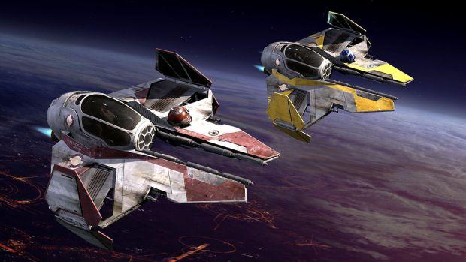

**Jedi Starfighter**

*First Appearance: Attack of the Clones*

The next in the roster of heroes’ ships is the Aethersprite-class light interceptor, more commonly known as the Jedi starfighter and popularized by Anakin and Obi-Wan in the Prequels. With their bright colors and talkative astromech droids, these ships contributed to the characters of the Jedi and looked pretty cool while they were doing it, especially twisting around in the beautiful Battle of Coruscant at the beginning of ***Revenge of the Sith***. Like the Jedi, the Aethersprites are agile and quick—and didn’t fare very well in Order 66.

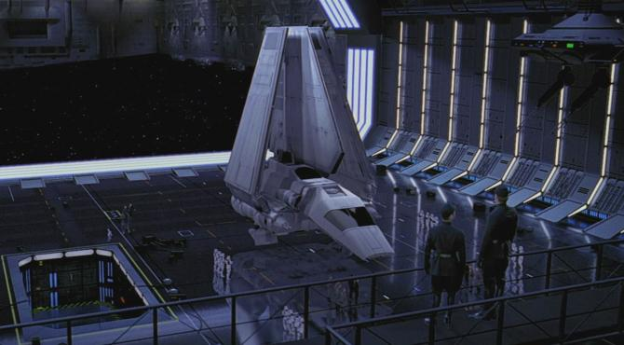

**Lambda-class T-4a Shuttle**

*First Appearance: Return of the Jedi*

While the TIE fighter is the iconic Imperial ship, with its screeching noise, the Lambda-class shuttles were iconic Imperial vessels in their own right. In weird contrast to the Mon Calamari cruisers used by the Rebellion, the Lambdas have an organic symmetry to them, like a spiny underwater fish. The Sentinel-class shuttle is very similar in shape, but was developed slightly earlier, and this is the ship you're more likely to see on ***Star Wars Rebels*** than in the movies. Both the Empire and Darth Vader use the Lambda shuttles to travel between Imperial capital ships and the Death Star.

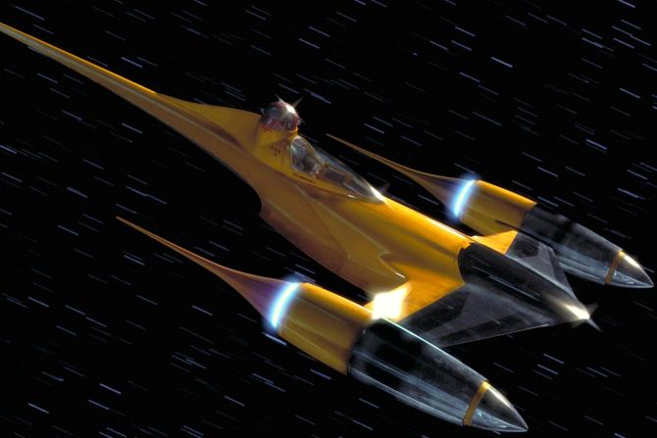

**N-1 Naboo Starfighter**

*First Appearance: The Phantom Menace*

Like the Sequel Trilogy, the Prequels brought more color to the starfighters of the galaxy, enabled by more advanced technology and symbolic of a galaxy that hadn't yet fallen into the Dark Times. The bright yellow, needle-tipped Naboo fighters serve the same role as the X-Wings in the Original Trilogy, as the front line fighters of the Naboo force. They were used by the local Naboo Royal Security Forces, but were more than capable of taking out a Trade Federation droid control ship.

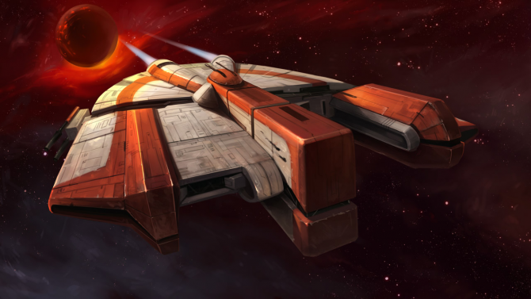

**Ebon Hawk**

*First Appearance: Knights of the Old Republic (Game)*

While the Ebon Hawk shares some of its flattened UFO shape with the Millennium Falcon, its role as the literal flagship of the ***Knights of the Old Republic*** games matches the Falcon in another key way too: the ship becomes almost like a character in its own right. Both Darth Revan and the Jedi Exile used this ship on their journeys across the galaxy. The player spends hours there getting to know the crew and preparing for the war either for or against the Sith. Formerly the weapon of a crime lord, Ebon Hawk is put through its paces too, with turret guns powerful enough to tear apart Sith starfighters.

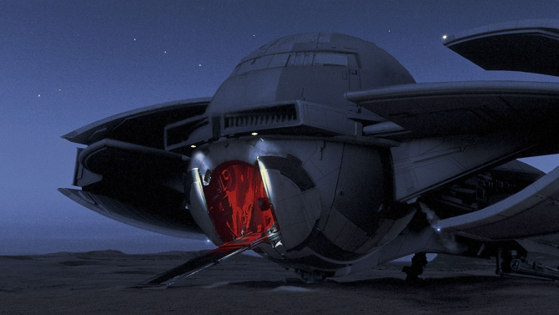

**Scimitar Sith Infiltrator**

*First Appearance: The Phantom Menace*

Darth Maul’s starship didn’t get a lot of screen time, but its black paint and folded wings give it the attitude of a stooping bird of prey, adding to the Sith Lord’s fearsome appearance in ***The Phantom Menace***. The Scimitar got some more screen time in the ***Star Wars*** comics, where it was recently the site of one of Lando Calrissian’s adventurous heists. Something else we never see in the film is the ship’s stealth capabilities, which might have allowed it to get in and out of the blockade over Naboo. The curved wings are reminiscent of later TIE fighters.

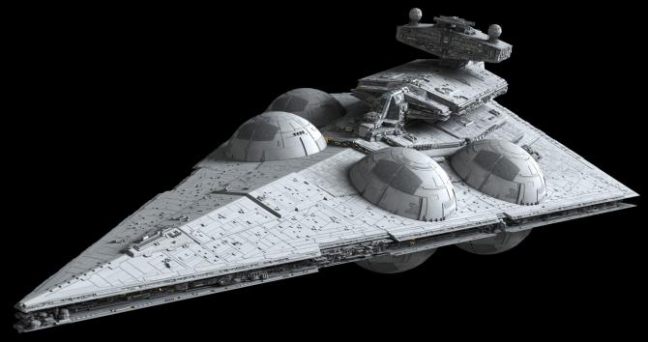

**Interdictor Star Destroyer**

*First Appearance: Rebels*

The Interdictor Star Destroyer was the next step in Imperial technology on ***Star Wars Rebels***. While packing the punch of a Star Destroyer, it can also force ships out of hyperspace using its gravity well generators. The Interdictor changed the way the Rebel fleet had to think about their movements. Although it’s still basically impossible to detect where exactly a ship is from hyperspace, with Interdictors in use in a blockade, the Imperials didn’t have to—they could just tug out any ship that approached them, and then bring the Star Destroyer’s armament into play. In Legends, the Interdictor was its own class of Star Destroyer. Things seem to be progressing slightly differently—or at least at a different rate—in the new canon, with experimental gravity well projectors affixed to an existing Star Destroyer in ***Rebels***.

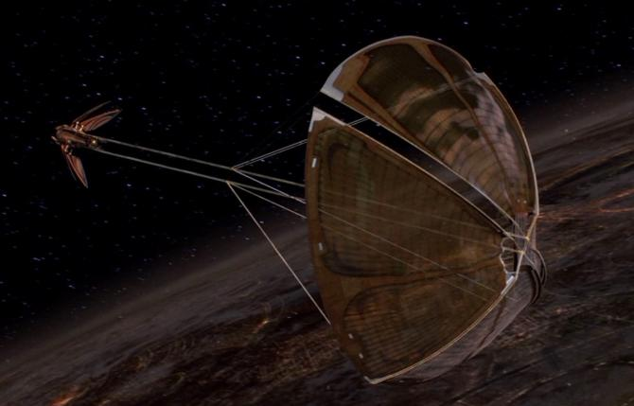

**Solar Sailer**

*First Appearance: Attack of the Clones*

Count Dooku and Asajj Ventress both use these elegant ships on their solo journeys across the galaxy. Dooku's solar sailer makes for a colorful, unexpected visual in the Prequels, as it unfurls its reflective sail. These ships had to be small, because of the way they operated. Solar sailers used lasers and tachyon streams pushing against the sail to propel themselves. Also because of this, the sails had to be enormous in order to enable the vessel to go into hyperspace, making this kind of ship rare and difficult to produce. Their unique look sets them apart from anything else ever seen in ***Star Wars***, though, and gives Ventress and Dooku a lot of style points.

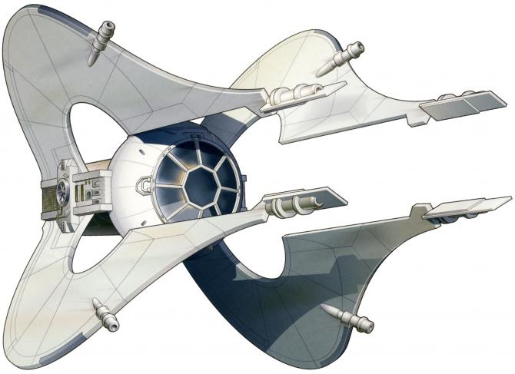

**Clawcraft**

*First Appearance: Specter of the Past*

Speaking of unique, one of the most unusual-looking starfighters in***Star Wars*** doesn’t appear in the movies at all. The Chiss clawcraft that appeared in the Expanded Universe looked like it sounded—swept-forward struts gave it the appearance of clawed hands partially closed, all stemming from a spherical cockpit. These ships aren’t completely alien, though. The symmetrical design lacking aerodynamic wings looks similar to the TIE fighter, but perhaps more wild, suitable for a militaristic alien culture. Chiss pilots—and the human Jagged Fel, who was born and raised in Chiss space—were critical during the Yuuzhan Vong wars that played out in ***The New Jedi Order*** book seres, and could hold their own against either X-Wings or the Yuuzhan Vong’s living ships.

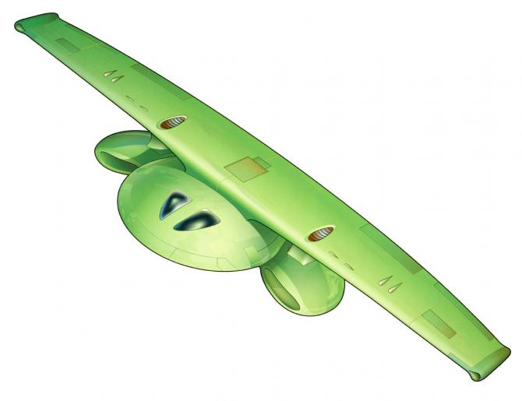

**Zonama Sekotan Shuttle**

*First Appearance: The New Jedi Order series*

Speaking of living ships, some of the fastest ships in the galaxy came from a living planet. ***The New Jedi Order*** series was full of all kinds of biological weirdness, starting with the Yuuzhan Vong’s bioengineered technology. The living planet Zonama Sekot is like an inverse reflection of these villains, and so it has its own living weapons—ones that can be sculpted into ships that create a psychic connection to their pilots. Obi-Wan and Anakin got to know Zonama Sekot during the Prequel era as well, before the planet disappeared for decades, taking its technology with it.

*- Megan Crouse*

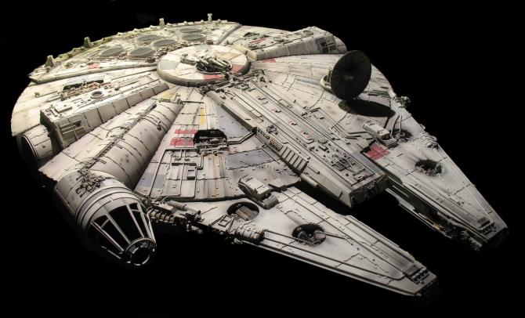

**Millennium Falcon**

*First Appearance: A New Hope*

Don't panic—we didn't forget the fastest hunk of junk in the galaxy! I'd say this is the most iconic starship in all of ***Star Wars***. At the center of the entire Original Trilogy (and it makes a look-and-you'll-miss-it cameo in the Prequels, too!), the Falcon rightfully became one of the standout icons of the early ***Force Awakens*** promotional campaign, alongside Kylo Ren's lightsaber. The Falcon spans much of the film saga, and if you delve into the Expanded Universe, it has quite the history of names, paint jobs, and owners. Most famously, Lando Calrissian lost the ship to Han Solo in a card game. And while you'll sometimes wonder why so many people cherish this "garbage" ship, as Rey so eloquently puts it in the latest ***Star Wars***adventure, you can always assume the Falcon still has some surprises left in her sweet heart, including secret storage compartments underneath the floor panels and twin AG-2G quad laser cannons that more than make up for the ship's very moody hyperdrive.

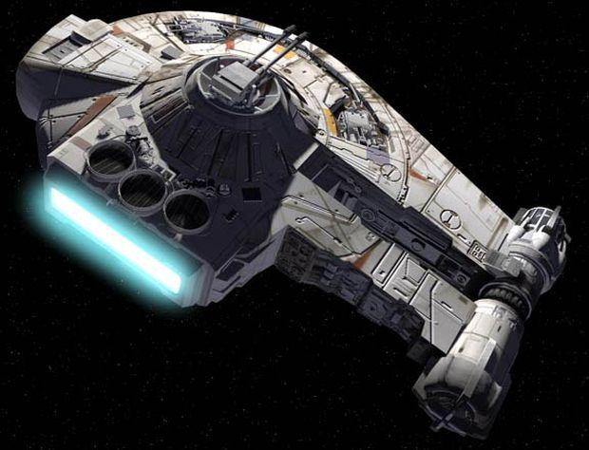

**Outrider**

*First Appearance: Shadows of the Empire*

Corellian smuggler Dash Rendar is clearly supposed to be a stand-in for Han Solo while he's still frozen in carbonite in the ***Shadows of the Empire***multimedia event from the 90s. And the Outrider does the same for the Millennium Falcon, down to the familiar cockpit design. The ship was designed by Doug Chiang, who later worked on designs for the Prequels and ***The Force Awakens***. While the Outrider is very similar to the Falcon, it stands out for being an iconic ship for one specific story, something that doesn't happen often in ***Star Wars***, which has often put our favorite Corellian freighter at the center of its adventures. The Outrider was later edited into a shot of the special edition of ***A New Hope***.

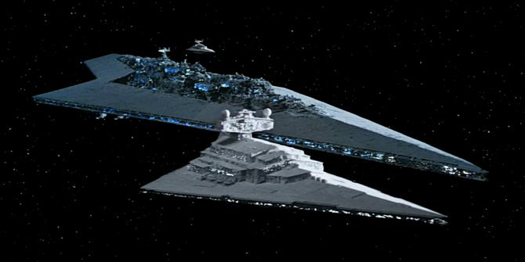

**Super Star Destroyer**

*First Appearance: The Empire Strikes Back*

You absolutely remember Darth Vader's flagship, Executor, from ***The Empire Strikes Back*** and ***Return of the Jedi***. The ship that hunted Luke Skywalker and the Rebellion was the same one that later crashed into the Death Star II's surface during the Battle of Endor. It's quite poetic that it's a Rebel A-Wing—one of the fleet's smaller fighters—that ultimately deals the killing blow. Still, the Super Star Destroyer (or Executor-class Star Dreadnought) is a sight to see, as it overshadows the Star Destroyers that once loomed over our heads in the opening scene of ***A New Hope***. Surprisingly, the Executor had a pretty short lifespan of almost four years before its ultimate destruction. Another Super Star Destroyer, Ravager, became the Empire's prized possession in ***Aftermath***, before it was also destroyed in the Battle of Jakku. It's the same fallen Star Destroyer we see in ***The Force Awakens***!

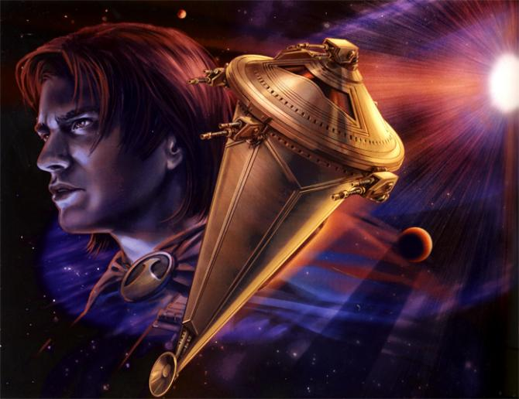

**Sun Crusher**

*First Appearance: Jedi Search*

While it's not much larger than a starship, the Sun Crusher is one of the most devastating superweapons ever created, capable of turning a star into a supernova and destroying entire star systems. And it's nearly invincible due to Quantum-crystalline armor, which could repel any laser blasts and withstand any collision. This little ship ripped through the bridge of a Star Destroyer and even withstood a superlaser blast from a prototype Death Star! Good thing the Empire never quite got a chance to use this ship against the Rebellion...

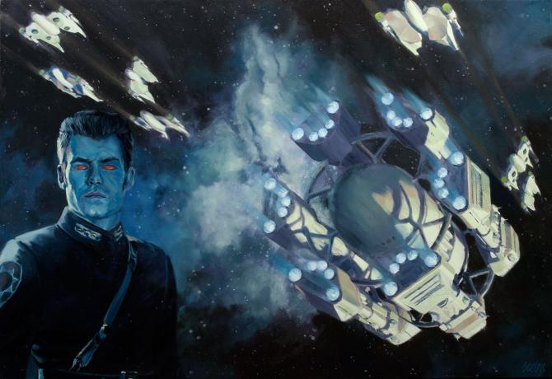

**Outbound Flight**

*First Appearance: Survivor's Quest*

Outbound Flight wasn't as much one ship as it was a combination of six Dreadnaught-class heavy cruisers connected by a central fuselage. While the design is cool enough, the ship's purpose is even more captivating: to venture into the Unknown Regions of the galaxy and search for extragalactic life. Yes, this was basically ***Star Wars***' own version of the Starship Enterprise, even if it was ultimately fated for a doomed expedition. This ship makes appearances or is mentioned in much of writer Timothy Zahn's ***Star Wars*** work.

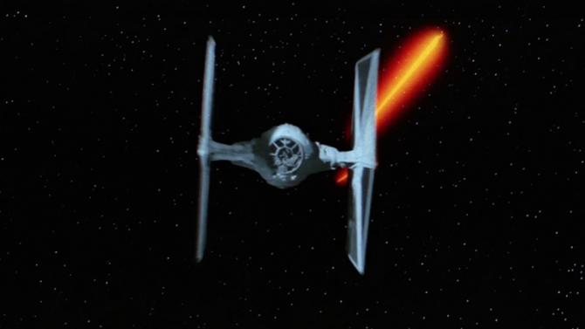

**TIE Fighter**

*First Appearance: A New Hope*

Few can forget the cry of a TIE fighter, as it zooms over their heads or right at them at dangerous speeds. Although it is absolutely the Empire's most expendable starship, it is also its most iconic. The original TIE fighters from ***A New Hope*** were white in color, while the ones in ***Empire*** and ***Jedi*** were a bit grayer, with blue-ish hues. The signature shriek of the fighter was created by combining an elephant's scream with the sound of a car driving on a wet road.

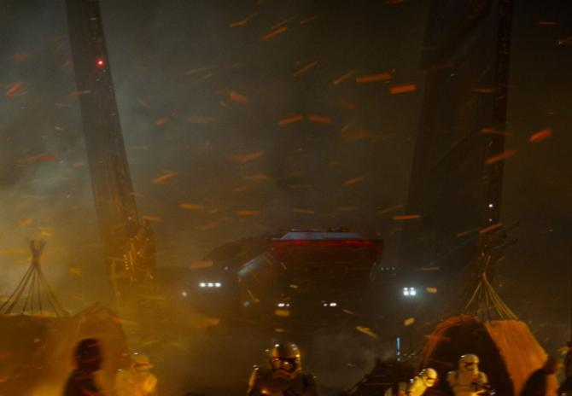

**Kylo Ren's Upsilon-class Command Shuttle**

*First Appearance: The Force Awakens*

We don't actually see Kylo Ren's command shuttle in much of the action in ***The Force Awakens***, even though it comes equipped with twin laser cannons. But when it does come down for a landing, like a hawk descending on its prey, it is one of the coolest sights in the entire film. It's foldable wings puts the Upsilon-class shuttle in the same family as the Lambda, which is higher up on this list. The winning characteristic of the ship is just how menacing it looks. It basically personifies Kylo Ren's vicious brand of evil.

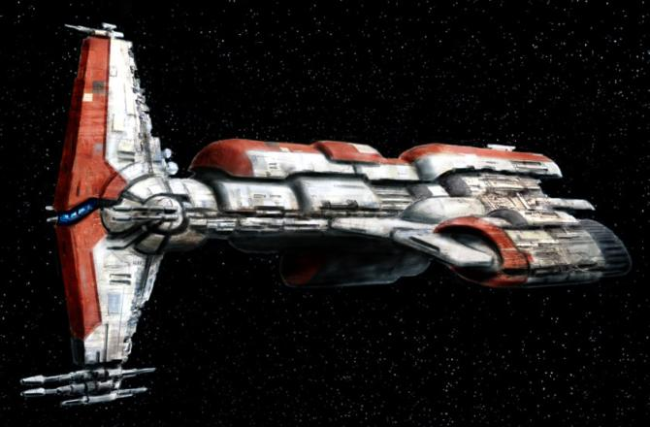

**Hammerhead-class Cruiser**

*First Appearance: Knights of the Old Republic (Game)*

The ***Knights of the Old Republic*** series is responsible for many of the best ships in ***Star Wars***. This Hammerhead-class Republic cruiser is the second of three on this list. Both the Endar Spire and Harbinger are key ships in the games, tied to the ongoing war between the Republic and the Sith. Few who have played the games can forget running through the hallways of a doomed Endar Spire, as it gave in to the Sith assault. Or the approaching Harbinger, the ship piloted by Darth Sion, a Sith hell-bent on hunting you down once and for all. For me, my all-time favorite Hammerhead moment is when a bunch of them team up to take down the Star Forge at the end of the first game. So good. This ship is set to make its first new canon appearance in ***Star Wars Rebels*** episode "A Princess in Lothal."

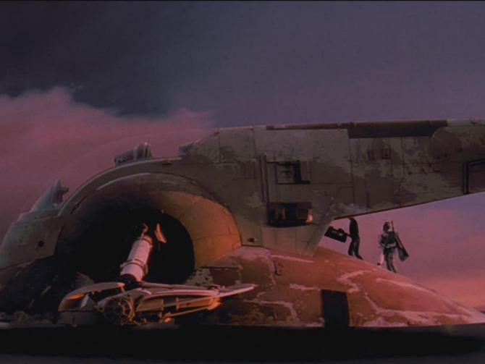

**Slave I**

*First Appearance: The Empire Strikes Back*

For the first few years of its popularity, we didn't even see the Slave I in battle, and we wouldn't see what this ship could really do on screen until ***Attack of the Clones***. Like its bounty hunter pilot, the ship is outfitted with several weapons, including laser cannons, seismic charges, and projectile launchers. Make no mistake about it, though, this ship is most famous for being Boba Fett's chosen mode of transportation. And its unique design also helps it stand out.

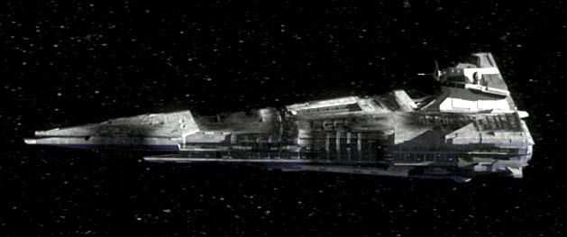

**The Ravager**

*First Appearance: Knights of the Old Republic II*

The Ravager is awesome because it's barely able to hold itself together at all, but is still one of the most threatening ships in ***Star Wars***. This Centurion-class battleship was used by the Republic during the Mandalorian Wars, which took place before the events of ***Knights of the Old Republic***. For all intents and purposes, Ravager was left a carcass in the aftermath of the Battle of Malachor V. Yet it was Sith Lord Darth Nihilus who willed it to fly again by using the Dark Side to power it and hold the ship together. With Ravager, Nihilus traveled around the galaxy, with the help of zombie Force slave pilots, feeding on the life energy of unsuspecting planets. It is one of ***KotOR II***'s scarier settings.